Project Simulation

Cognizant Business Model

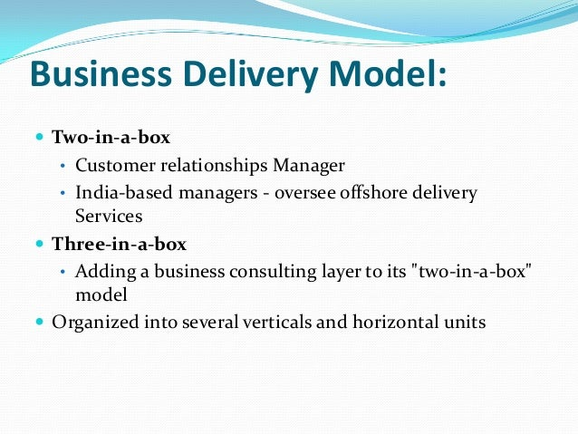

Consultant

**Roles**

**Roles and Responsibilities of the PM:**

* PM Should organize a call with the client and the team members to discuss the project requirements.
* Will introduce the team members to the client during the call
* After the call the PM will send the MOM of the call
* Follow up the team lead for the SRS, Design document and database schema.
* Update the client with the status of the project regularly
* Responsible for the client’s approval of SRS, Design document and database schema.

**Roles and Responsibilities of the Team Lead**

* Interacts with the PM for any clarifications
* Delegates the tasks to the team members
* Follow up the team members to complete the task on time
* Shares the completed SRS and design document to the Project Manager
* Responsible for the changes suggested by the project manager

**Roles and Responsibilities of the Developers**

* Should ask relevant questions to the client for proper understanding of the project requirements
* Note the requirements properly
* Should prepare the SRS and Design document and deliver it to the team lead on time. (Design can be a screen short from a relevant web site)
* Communicate to your TL for additional time if you need any

**Roles and Responsibilities of the Client:**

* The client interviews all the project team members to understand the skill set and experience before assigning the project.
* Document the skills and experience of the project members and share it with the Lead Client
* The client should produce the basic requirements of the project. (Two-page website – 1 – Login, 2- Registration page.)
* Set deadline for the delivery of the project.
* Follow up with the PM for the timely delivery of the project
* Approve the project on receiving the SRS, Design document and database schema.
* Client can suggest changes in the documents received

Process

**Step1**.

The PM should send an invitation to all the project members including the client. The invite should have a proper agenda for the meeting.

**Step2.**

The project team gets on a call along with the client to discuss the requirements.

**Step3.**

The PM sends a MOM to all the invitees after the call

**Step4.**

The PM sends a kick start mail to the Team Lead to work on the SRS and Design document stating the requirements discussed on the client’s call.

**Step5.**

The TL replies to PM’s mail and sends mails to the team members’ delectating the tasks.

**Step6.**

The team members complete their task and share the work with the TL.

**Step7.**

The TL collates the documents and sends them to the PM.

**Step8.**

The PM shares the documents with the client for approval.

**Step9.**

The client verifies and approves the documents.

**Step10.**

The PM thanks the client for approval and communicates to the team to start the project.

**Note:**

* All communication should be professional and through mail and calls.
* No informal communication is entertained during the activity.
* Everyone should be active in performing their roles.

Sample Design of Login Page

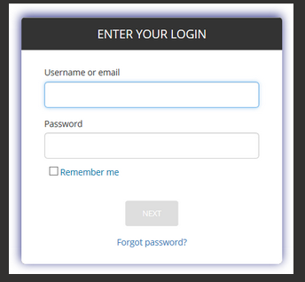

Design of a Registration Page

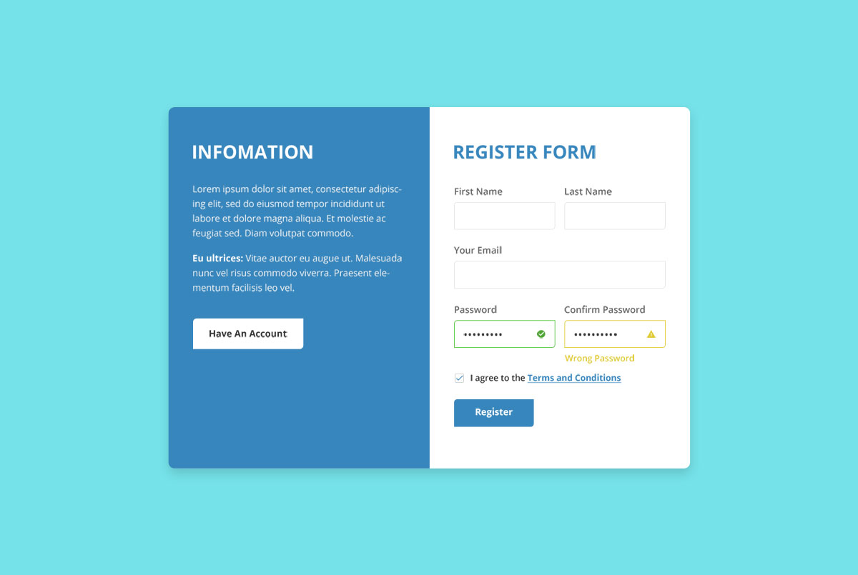

**Sample Agenda for the meeting organized by Project Manager**

Hi All,

Hope you all are doing great!

I am blocking your calendar for an important meeting on our new project discussion with our client and all other team members.

Agenda of this meeting:

1. Project members introduction and Interview by the client
2. Gathering all the vital details about the project.
3. Discussion about the deadline for SRS Document, Design Specification Document.
4. Discussion about the deadline of the project completion.
5. Panel Discussion regarding the project.
6. Closing Remarks

 I request everyone to attend the meeting on time.

Regards

Ayushraj Khare

Project Manager, Cognizant

**Sample details collected by the client during the interview conducted with the project members. These details will be sent to the Lead client by the client.**

**SKILLS AND EXPERIENCES OF PROJECT TEAM MEMBERS**

**PROJECT: DESIGN ABC BANK ONLINE WEBSITE** 

**DIKSHA (PROJECT MANAGER)**

* Skills
* Leadership,
* Communication,
* Time management,
* Negotiating,
* Team management,
* Critical thinking
* Experience:
* Worked on many projects as a project manager and successfully completed them on time with user satisfaction
* Managed a small group of peers on certain parts of the project.
* Managed the whole team, communicating with the customers, teammates and other people in the organization.

**LOHITHA (TEAM LEAD)**

* Skills:
* Communication and interpersonal skills
* Ability to negotiate and resolve conflicts
* Building commitment within the team
* Experience:
* Inspiring positive communication within them so that they can work together toward achieving goals.
* Organizing a study group
* Spotting a problem at work and finding a solution

**POORNIMA (DEVELOPER)**

* Skills
* Ability to complete tasks within deadlines
* Good knowledge of operating systems
* Has knowledge of databases which are required to manage data
* Has knowledge of testing to find bugs in the software
* Experience
* Worked on similar projects
* Designed projects that are more user interactive by using UI tools

**SRAVYA (DEVELOPER)**

* Skills
* Have knowledge in coding language in order to handle the project
* Have database knowledge which is required in managing data
* Have worked with the ide's prior so has knowledge in source control
* Experience
* Worked on similar project previously
* Has experience in creating functional and well-designed software tools

**NAYAN (DEVELOPER)**

* Skills
* Problem solving ability in analyzing the task given
* Good technical strength in java script and react
* Technically good in testing the codes and debugging
* Experiences
* Worked on many other projects with User interface designing
* Created and managed many database schemas.

**Sample Minutes of Meetings sent by the Project Manager to all the invitees**

**Subject: Minutes of Meetings-ABC project**

Hi all,

I hope you all are doing well.

Thanks so much for taking the time to meet the ABC project discussion today. The purpose of this meeting was to get to know the stakeholders who will be working for this project and to get on the same page about the specifications and requirements and discuss the project.

As a quick recap, we discussed:

* Roles of the team members and their skills and experience.
* Tasks that need to be done.
* Clarification of the problem.

We concluded that:

* We'll be drafting the SRS document for our client to review it for approval.
* We'll try our best to complete this task in the given time.

Our next steps for successful completion will be:

* Our Team lead Sesha Sai Madhav will assign tasks to developers.
* Developers will complete their assigned task in the given time.
* I will be taking updates from the team lead about the project.

We plan to meet again in 2 days, and I wish the team members all the best.

Regards

Utkarsh Mishra,

Project Manager

**Sample email sent by the Project Manager to the Client after the Call.**

Hi Prashant,

Hope you are doing well.

Thank you for sharing the problem statement.

I will have a discussion with my team and will share with you the detailed requirements along with the product requirement document by today.

Regards

Ayushraj Khare

Project Manager, Cognizant

M: 7999846163

**Sample 1 - Email sent by the Project Manager to the Team Lead after the Call.**

Subject: **Gear up - Project ABC**

Hi Madhav,

Hope you are doing well.

As we are aware of the discussion held in the ABC project meeting with the client and the team members, I am looking forward to an outstanding performance by our team in this project. I have a firm belief that our team will perform.

Here I am also attaching the specifications/requirements that I received from our client for a better understanding of the project.

Feel free to reach out to me, and all the best from my end.

Regards

Utkarsh Mishra,

Project Manager

Cognizant

M: 90304232333

**Sample 2 - Email sent by the Project Manager to the Team Lead after the Call**

Dear Team Lead,

I hope you are doing well.

Over the last meeting, we convened with the whole team and the client. We have gone through the project requirements of the client, and we shall commit straight away with the initial works.

The requirements of client are:

* Websites should be dynamic and user friendly.
* It should have a pleasant color combination.
* It should contain a login page and a registration page.
* Main module should deal with the accounts of the company and should show the investment, loss, profit and all the expenses.
* Websites should be quick, responsive and of high capability.

With the requirements clearly defined, we are now ready to officially start the project. We shall start by preparing the SRS and Design documents and get it approved by the client. I respectfully request you to instruct your developers to prepare the documents as quickly as possible.

Regards,

Kemburu Hima Bindu

Project Manager

M +91 9390410701.

**Sample email sent by the Team Lead to the Developers**

Hi Team,

I hope everything is going well at your end.

From the discussion by our team with the client in the client meeting held yesterday, you have to work on the SRS document and the Design document for the "Online Food Ordering Website" project as per the client requirements.

In our team:

1. Manoj will work on the SRS document
2. Vahini will work on the Design document for this project.

I request both of you to share the above-mentioned documents with me by 11th June 2022.

All the Best!

Regards,

Karthik Sai V M

Team Lead, Cognizant

**Sample email sent by the Developer to the Team Lead after completing the SRS document**

Hi Sesha Sai,

Hope you are doing well.

I want to inform you that the task assigned to make a design document for the ABC project has been completed and I have attached the design document with the mail.

However, if you have any queries regarding the document, you can contact me anytime. So we can start our work for the next phase at the earliest.

Thank you for your sincere support throughout the project discussion, without which it could not have been completed within this limited time.

Anshika Sahni

Project Developer

ABC project

Cognizant

**Sample email sent by the Team Lead to the Project Manager after receiving the SRS, Design document, and Database schema from the developers**

Hi Mallika,

I have attached the SRS, design document and database schema for your reference.

I hope this document meets the client's requirements. Please, let me know if anything is missing or needs to be changed.

After you have reviewed the documents, we can discuss further steps.

I am looking forward to hearing back from you.

Regards,

Prashant Aswani

Team Lead

Cognizant

M: 9691187069

**Sample email sent by Project Manager to Client after receiving the SRS, Design document, and Database schema from the Team Lead**

Hi Pragathi,

As we discussed with you, we prepared the SRS and Database design as per your requirements. Please review and provide us with feedback.

We are open to hearing your thoughts on this. After your approval, we will move forward with the project.

Regards

Saurabh Suman

Project Manager, Cognizant

**Sample email sent by Client to Project manager approving the documents.**

Hi Saurabh,

This email is to inform you that we have approved the latest SRS and database design of Medical Pharmacy web project sent to us on 11-06-2022.

Please get started with the further steps of developing this project.

Regards,

Pragathi R A

pragathi.ra@cognizant.com

M +91 8861875701

**Sample email sent by Project manager to Team Lead after approval of the client.**

Hi Sandeep,

Hope you are doing well.

As we discussed with the client about the project, and after sending the SRS and database design, our client is happy with your work. Now I am looking forward to an outstanding performance in development also.

I am also attaching the SRS and database design which have been approved by the client.

Feel free to contact me if you have any queries, and all the best from my end for development.

Regards

Saurabh Suman

Project Manager, Cognizant

Minutes of Meeting

|  |  |  |  |
| --- | --- | --- | --- |
| **Meeting Date and Time** | 09-Jun-2022, 4:30 PM | **Minutes Drafted Date** | 09-Jun-2022 |
| **Meeting Organizer** | Daithiya Sudan | **Meeting Title** | Project Simulation Meeting |

|  |
| --- |
| **Attendees** |
| * Rishabh Bahukhandi - Team Leader * Daithiya Sudan          - Project Manager * Siri Ranabothu          - Developer * Yerram Karthik          - Developer * Mahesh                     - Client |

|  |
| --- |
| **Brief Description / Agenda** |
| * Gathering all the important details about the project. * Understanding the needs and requirements of the client. * Discussion about the deadline for MOM, SRS Document, and Design Specification Document. * Discussion about the deadline of the project completion. * Panel Discussion regarding the project. * Closing Remarks |

|  |  |
| --- | --- |
| **Summary of the discussion** | |
| **No** | **Items Discussed** |
| 1 | In the meeting, Mahesh discussed the needs and requirements of the new project and interviewed the developers on their skill sets for the project. |
| 2 | There was also a discussion about the deadline for MOM, SRS Document, and Design Specification Document. |
| 3 | The technical team organized a demonstration of the features of the website. Everyone in the meeting agreed that we should proceed with the design. |
| 4 | After the design was agreed upon, the date for the project completion was discussed and fixed. |
| 5 | In a conclusion, Daithiya Sudan discussed the summary of the meeting. |

|  |  |  |  |
| --- | --- | --- | --- |
| **Meeting Conclusion** | | | |
| The meeting concluded with everyone on the team recommending proceeding with the website design. | | | |
| **Action Items** | | | |
| **No** | **Action Item** | **Owner** | **Due Date** |
| 1 | Provide the software requirement system | Siri Ranabothu | 15-Jun-22 |
| 2 | Start development of the new site design. | Yerram Karthik | 09-Aug-22 |
| 3 | Provide estimation for the new site cost. | Daithiya Sudan | 09-Aug-22 |
| 4 | Review performance issues and recommend remediation. | Rishabh Bahukhandi | 11-Aug-22 |

|  |  |  |  |
| --- | --- | --- | --- |
| **Decision Register** | | | |
| **No** | **Decision** | **Decision By** | **Date** |
| 1 | Start work on the new design. | Everyone | 28-Mar-15 |
| 2 | Hire a contractor to do performance testing. | Siri Ranabodhu | 28-Mar-15 |

**SRS Document**

**Databases: -**

· A Users table which will keep information of users like- name, email, phone, password and similar identity fields.

A user will have a carts account where he can add products, and his previous orders also need to be saved.

· A Sellers table which will contain identity details like Users table and A seller will have details like seller-id, GST No. and his License number.

· A Products table will contain details of the product's category, price, seller-id, and other product related fields.

**Interfaces: -**

**Admin/Seller: -**

· Login/Signup: If a Seller is new to the system, he must fill a signup form with details like- GST No., his Name, Mobile No., Address, E-mail etc. A unique seller-id will be generated for him, then he needs to add a Password.

· Seller’s authority: A seller can Add/Delete/Update/Read (CRUD) the product details which he owns.

· Dashboard: A seller can see the orders which users place for. If the product is in stock then, place the order, if out of stock, then notify the user for the same.

· Credit account: When a user pays for his product, the money will be added into the seller's credit account.

· Product cancellation: Whenever a user cancels or returns a product, the product amount will be deducted from the seller's credit account.

**User: -**

· Signup: If a User does not have an account, then he/she must fill a Signup form in which he/she needs to provide his/her Name, Mobile No., Address, E-mail. A unique customer-id will be generated for him then he needs to add a Password.

· Login: If a User has an account, then he needs to login using his customer-id or E-mail and password. If data does not match then show “Account does not exist”.

· Credit Account: A User will also have a Credit Account where he can add money and can use those credits to buy something in future.

· User’s Authority: A User can do following things:

1. View Previous Orders: Users can view all the orders that have been placed by him till date.

2. View/Place an Order: Users can view various things like Electronics, Pantry, Clothing etc. Users can also view Comments, Ratings of the product that he/she is planning to buy.

3. Cancel/Return Ongoing Order: User can cancel his orders within 10 days of purchase and the refund amount will be added to his Credit Account.

Product Offers: -

· If a User pays using his credit account then he will get a 5% discount.

· If a User has a total purchase amount between Rs10,000-20,000(inclusive) then he will get a 10% discount on his purchase.

· If User has a total purchase amount of more than Rs 20000 then he will get a 20% discount on his purchase.

**Payment System: -**

· Users can pay securely through a payment portal.

· If payment is not successful then the user will be notified.

· A User can also pay through his available credit in his credit accounts